Sample Answers for the Sample Paper uploaded in March 2017

Q1.

(a) Steps followed in designing a database:

* Study the business scenario and identify the entity types and possible relationships between them.
* Draw an ER diagram to model the DB to support the business requirements.
* Map the ER diagram to the Relational Model.
* Normalize each relation in the DB to at least 3NF.
* Create the Normalized tables using SQL.

(b) Relational database consists of normalized relations or tables. A relation is a database table with the following special properties.

* Distinct name for each table
* Distinct column names
* Distinct tuples or rows
* Values for each column are coming from a single domain

(c) File based Approach:

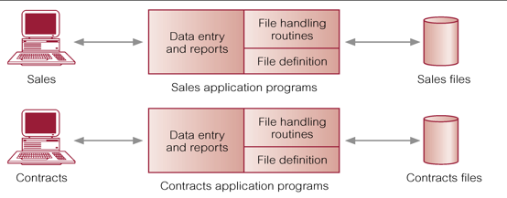

Database Approach:

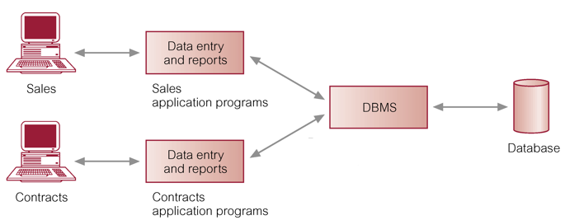

In the DBMS approach data is centrally stored together with the metadata. All requests for data has to go through the DBMS, improving the security. DBMS's comes with improved performance, security, backup/restore and other utilities. SQL also enhances the access to data and accommodating new business requirements.

(d) SQL is a 4th generation language, facilitating an English Like declarative statements. Without much technical knowledge SQL can be used to access a DB.

(e) When the attribute A is given, if attribute B's value can be uniquely determined, then we say B is functionally depend on A. (A --> B). Functional dependencies are used in the process of normalizing a relation/table, which is an required step in designing a relational database.

Q2. Need to draw an ER diagram by identifying the entities and relations between them. Each valid entity type can score 1 mark up to a maximum of 8 entity types. Each valid relationship type with cardinalities can score 1 mark up to a maximum of 8 relationship types. Reasonable attributes can score up to 5 marks (need not be comprehensive). Valid assumptions can score up to 4 marks

Q5.

student

|  |  |  |  |
| --- | --- | --- | --- |
| StudentId | FirstName | LastName | StudentGrade |

MemberOf

|  |  |
| --- | --- |
| **StudentId** | **TeamId** |

team

|  |  |
| --- | --- |
| TeamId | **class** |

LabSection

|  |  |  |
| --- | --- | --- |
| class | LabAssistant | DragExpWeek |

DragExpRun

|  |  |  |  |  |  |
| --- | --- | --- | --- | --- | --- |
| RunNumber | InitPosition | Time | distance | **TeamId** | **class** |

One can replace the class attribute in the above tables with the 4 attributes CatalogNumber, year, semester and section.

(b) Assuming all the attributes in the above tables are atomic, and as there are no lists, arrays or repeating groups we can conclude that all the above tables are in 1NF.

**Functional dependancies:**

StudentId-->FirstName, LastName, StudentGrade

StudentId-->TeamId

TeamId-->class

class-->LabAssistant, DragExpWeek

RunNumber-->InitPosition, Time, distance,TeamId, class

All above functional dependencies are primary key dependencies.

As there are no partial dependencies in any of the above tables they are all in 2NF.

Furthermore, as there are no transitive dependencies in any of the above tables they are all in 3NF.

Q6.

(a) create table viewing( rno varchar(5) references renter(rno),

pno varchar(5) references property_for_rent(pno),

vdate date, comment varchar(30),

primary key(rno,pno) );

(b) select * from properties_for_rent;

(c) select * from properties_for_rent

where pno not in ( select pno from Viewing where date > sysdate()-90);

(d) select fname, lname from staff where sno in

( select sno from property_for_rent group by sno having count(*)>5 );

(e) select * from properties_for_rent

where bno = (select bno from branch where city = 'Kandy');

(f) update property_for_rent set rent=rent*1.1;

(g) update owners set address='whatever the address' where ono='O0012';

(h) insert into property_for_rent values('P001', 'First Street', 'Green Park', 'Homagama', null, 'House', 4, 40000, 'O001', 'S002', 'B003');

(i) delete from properties_for_rent where pno='P0023';